Nature Playgroup

Getting preschool children and their families to directly experience the natural environment is a marvellous thing in so many ways! It promotes a love and respect for the environment which research shows often endures throughout their lives.

There are some Nature Playgroups around NZ. Play and Learn NZ operates in various locations around Auckland: https://www.playandlearn.net.nz/nature-playgroup

Nature Playgroup is a chance for children from 0-6 years, whanau and educators to get out there and explore. Nature Playgroups are parent, home-based educator or early childhood teacher led. It is an opportunity for children to do what they have always done - climb trees, make huts, find insects, go on bush walks, play games and a social opportunity for the adults who come with them.
​
Nature Playgroup is a group of people who want their children to have regular experiences in nature. It is a unstructured time to play in nature. In a world where children't lives are so busy its great to have some scheduled 'downtime' where they can explore, challenge themselves, learn about risk taking, develop confidence and make some great friends.

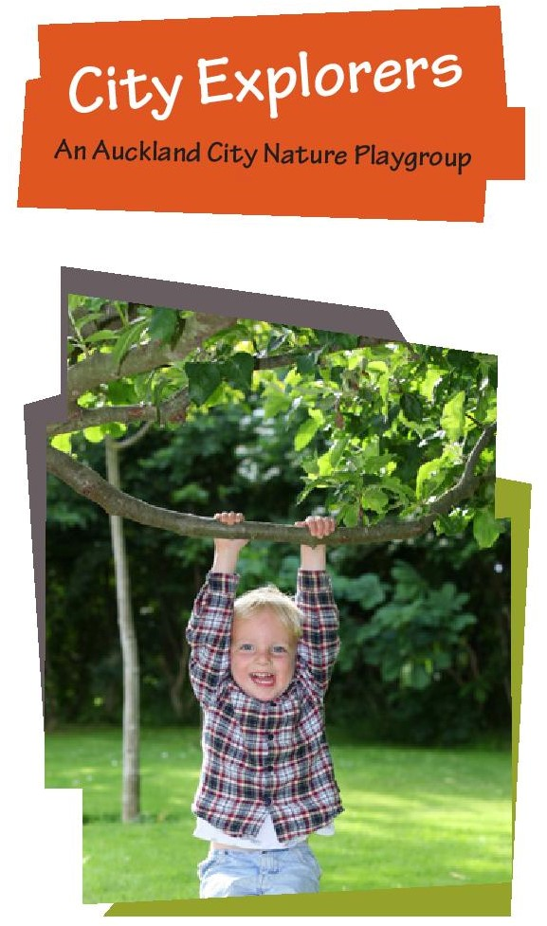
Jill Kayser ran a Nature Playgroup called ‘City Explorers’ in an inner city Auckland park during 2018.
City Explorers recognises the importance of children playing, exploring and learning in a natural environment. Our playgroup takes place outside in all seasons (weather permitting). we meet every Friday morning in Albert Park, a beautiful “playground” of giant trees, green grass, flowers and more that invites children to be adventurous and explore! (look out for our pink Splice vests to find us.) City Explorers nature playgroup encourages “free play” rather than organising a structured programme. Children are given opportunities to do what kids have done for centuries—play with nature, climb trees, splash in puddles, make mud cakes, care, share and have fun. As they play in this amazing Auckland City “backyard” they build resilience, cooperation, perseverance, playfulness, risk taking, curiosity, empathy and a love for their environment.

City Explorers Nature Playgroup Video: https://www.youtube.com/watch?v=i0Ius3_MXO4

‘Lulastic’ website includes a guide for establishing a Nature Playgroup:
https://lulastic.co.uk/parenting/how-to-start-a-nature-play-group/
Lulu writes:
“There is a window for young children, under fives, where they are learning about their place in the ecosystem, their “Ecophyscial selves”. This sense of connectedness then stays with them their whole life – if it is not nurtured they are far more likely to be fearful of nature and only at home in places manmade.”
(WILTING RAINBOWS AND 20 OTHER REASONS TO PLAY IN THE WILD, https://lulastic.co.uk/parenting/20-reasons-to-play-in-the-wild )

For help in considering what policies and procedures are needed to ensure health and safety, contact jillkaysernz@gmail.com

